

**Educational Traveling**



**Educational Travelers**

**Documentation**

Contents

1. Team 2

1.1 Rumen Ivanov Petkov 10V – Scrum Trainer 2

1.2 Bozhidar Petrov Boyadzhiev 10V – Backend Developer 2

1.3 Kaloyan Branimirov Lambov 10A – Backend Developer 2

1.4 Dimitar Georgiev Yoldov 10B – QA Engineer 2

2. Goal 3

3.Stages of realization 3

3.1 Planning 3

3.2 Process of work 3

3.3 Testing 3

4. Realization 4

5. Site description and structure 4

5.1 Structure 4

5.2 Description 5

6.Table with functions and explanations 5

7. Coclusion 6

# 1. Team

# 1.1 Rumen Ivanov Petkov 10V – Scrum Trainer

I am the leader and I organized my team. I worked on the presentation and on the documentation. I created the repo and the files inside so that my team could work on them. I made projects and issues so we could work better.

# 1.2 Bozhidar Petrov Boyadzhiev 10V – Backend Developer

I worked on the C++ code. I made the menu of the game and the logic. Together with Kaloyan we made buttons for each country and made questions with four options to choose. I also made an option which asks the user with what type of transport he want to travel, a file which saves the data of the user while he is playing and add the oppurtunity this data to be deleted.

# 1.3 Kaloyan Branimirov Lambov 10A – Backend Developer

I worked on the C++ code. I made the animations in the game for each type of transport and the logic. Together with Bozhidar we made buttons for each country and made questions with four options to choose. I also add comments to the code.

# 1.4 Dimitar Georgiev Yoldov 10B – QA Engineer

I made test cases which I included in the QA documentation. With them I checked if the code works and when there were errors, they were solved. I also made the test plan, team logo, the design of the game and had to think of different ways of "breaking" the code.

# 2. Goal

Our goal was to create a game related to History and Geography using C++. We wanted to include in our game an option to travel with one of three possible means of transport. The user started with 300lv and has to answer to 20 different questions to gain money to pay for the traveling. He can choose to which country can go by pressing the buttons which are placed on the Europe map for each country. When he hasn’t got enough money to pay to travel and he answer all the 20 questions the game ends. And the user has to enter his name. After that the game redirects him to website which the top 10 users with the highest score.

# 3.Stages of realization

# 3.1 Planning

After we formed our team and assigned the roles, we organized when our meetings would take place.

# 3.2 Process of work

We decided what the project is going to include. During the whole process we used Microsoft Teams to communicate with one another. We met frequently to discuss about the progress, the due dates that the Scrum Trainer assigned to us and help one another.

# 3.3 Testing

Our QA Engineer made sure that all used functions, cycles work and pointed out the bugs and mistakes, so that they could be fixed as soon as possible**.**

# 4. Realization

We started our work using Microsoft teams as a communication platform and C++ as a programming language. We discussed ideas and gave different suggestions on how each of us sees the final product. After we reached a consensus, we decided which part of the project everyone should do and we started working. When someone have new ideas for making our project better, we discussed them and then continue working. If there were any problems we helped each other in the process of work.

# 5. Site description and structure

# 5.1 Structure

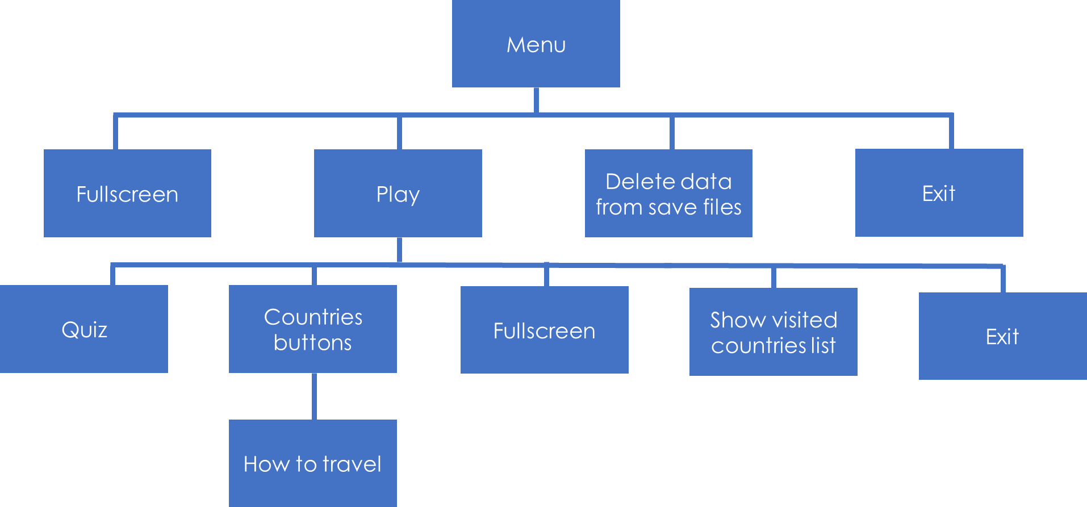

# 5.2 Description

Here in our game, you will find the menu of the game from which you can exit our game, choose a fullscreen option and then play the game or just press the play button and start playing. And after you start playing the game screen shows you a map of Europe where you can start answering questions to increase the amout of money you have, and then choose the country which you want to travel. To choose a country you have to press a button with its name. Then you have to choose between three options how would you like to travel. The game ends when you answer all the questions and you don’t have enough money to travel to the country which you want.

# 6.Table with functions and explanations

| Function name | Description |
| --- | --- |
| void callCountry() | When you click the country, you want to travel the function calls animation for traveling to start and deletes the button for the chosen country. Only its name stays on the screen after pressing the button. |
| void questions() | Gives to the user 20 question with 4 different answer from which, one is correct. |
| void start() | Shows the user the rules for the game and explains what he has to do. |
| void balance() | Shows the amount of money the user has while he is playing. Also, it saves this amount in money.txt file. |
| void countries() | Saves the name of the countries which the user has travelled to and placed their names in countries.txt file. |
| void questionAnswered() | Calculates how many questions the user has answered and saves the number in questionsAnswered.txt file. Also, it shows the number of the answered questions on the screen with the questions. |
| void clearSaveFile() | Clears the data of which the user has changed by playing the game. It returns the initial values of the variables that were changed while the user was playing. |
| void travelAnimation() | Save the current country you want travel to, so you can’t go back to it again. And makes animation for travelling with the chosen transport. |
| bool travel() | Makea window which asks the user how he would like to travel and gives him three options and their costs: plane, train and car. And when he chooses the transport, the function takes the money that the user needs to pay for the travelling. Then it saves the changed amount of money in money.txt file. |
| void highscore() | Show the points that user earns during the game on the game screen. It also saves these points in score.txt file. |
| void finish() | Indicates to callCountries() function to stop drawing buttons and finishes the game. |

# 

# 7. Coclusion

In the end, we achieved our goal and the final stage of our project. We learned a lot of things about game development and game design. The work journey was quite enjoyable, we had some difficulties which when you are in a team can be solved more easily and quickly.